Bamdir Non-Wood Forest Product Management & Marketing Plan
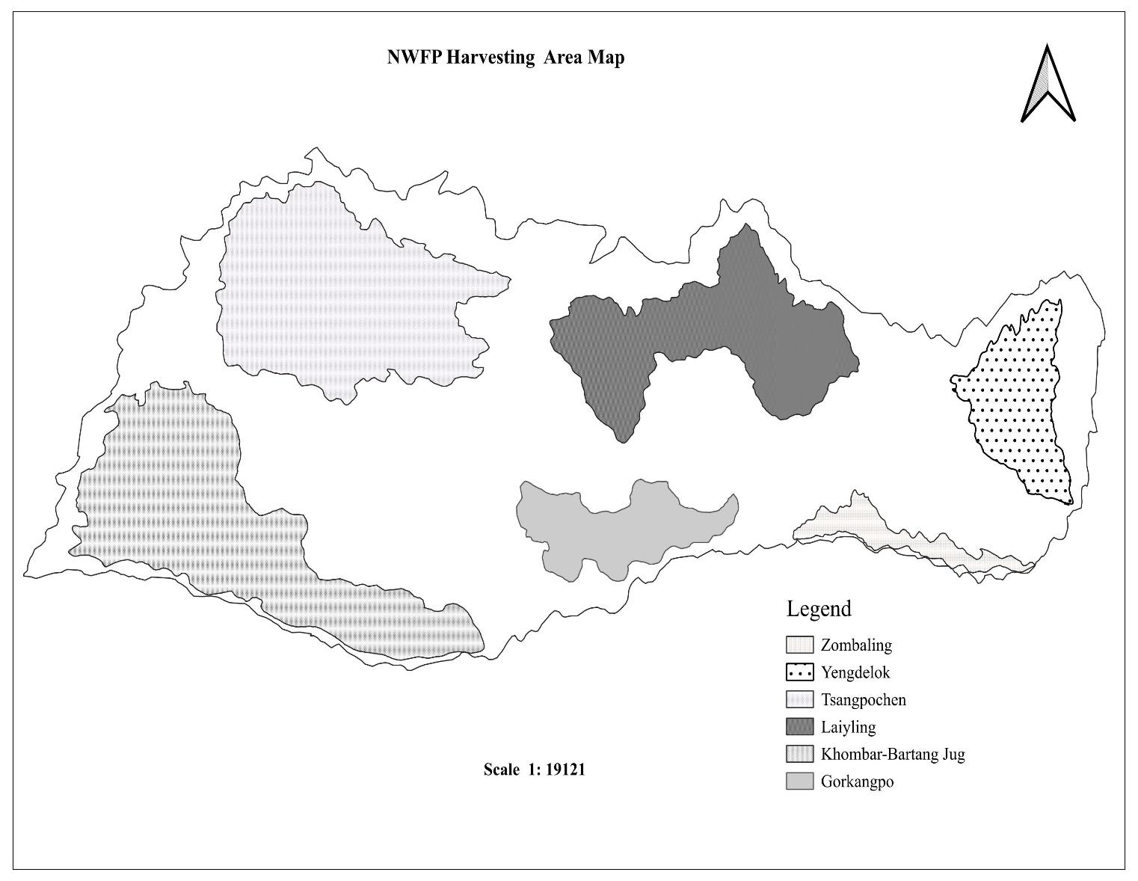
(1st Revision)

Bumdeling Gewog
Trashiyangtse
Plan Period :2025-2035

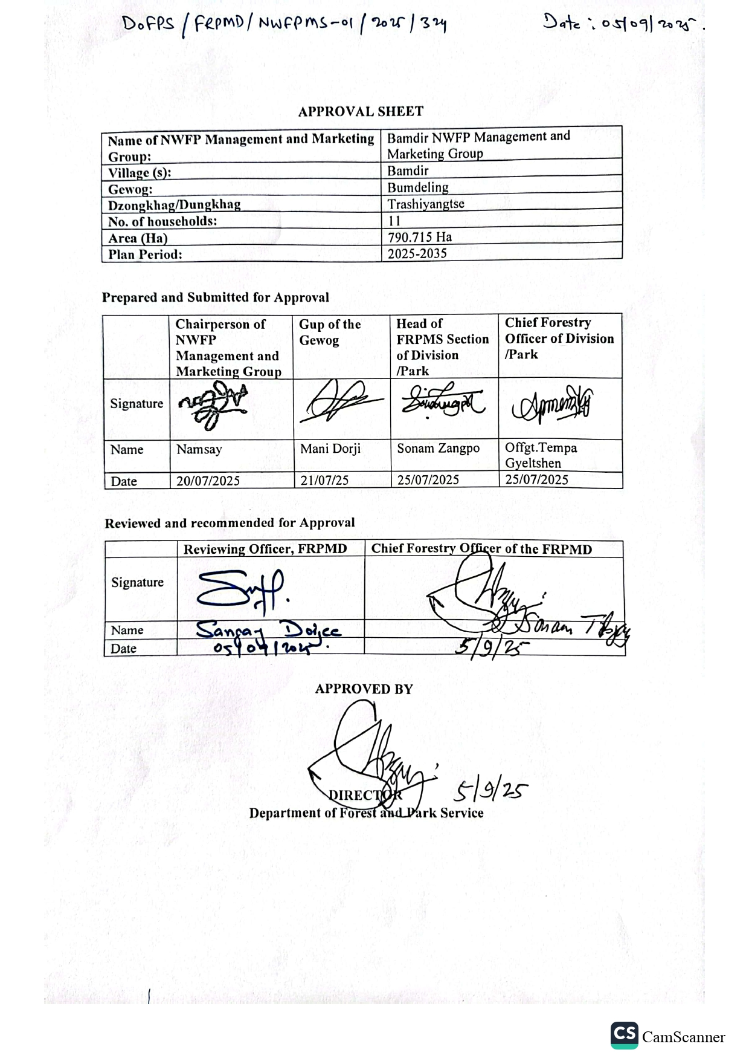

Content
Acronyms i
Summary of NWFP management plan (2019-2024) ii
PART A: BAMDIR NWFP MANAGEMENT AND MARKETING PLAN 1
1. Background 1
2. Management Objectives 1
3. Description of NWFP harvesting blocks 2
3.1. Tsangpochen Block 2
3.2. Khombar Barteng Jug Block 2
3.3. Laiyling Block 3
3.4. Yengdelok Block 3
3.5. Gorkangpo Block 3
3.6. Zombaling Block 3
4. Harvesting prescriptions for sustainable NWFP harvesting 4
5. Marketing and sales plan 5
6. Marketing arrangements 5
7. Benefits to the members 6
8. Benefits to the group 7
PART B: GROUP’S BY-LAW 8
10. NWFP management & marketing group 8
10.1 Membership Arrangement and Resignation 8
10.1.1New membership 8
10.1.2 Withdrawal of Membership 8
10.2 Responsibilities and rights of the members 8
11. Management Committee of the NWFP management and marketing group 8
11.1 Chairperson 8
11.2 Secretary 9
11.3Treasurer 9
11.4 Members 9
12. Tenure of the committee member 9
13. Incentives to the committee members 10
14. Source of income generation for group 10
14.1 Membership Fees/Annual Contribution 10
14.2 Collection from the sale of proceeds 10
14.3 Fines and Penalties: 10
15. Group fund management and utilization. 10
16. Conflict resolution 10
17. Meeting and Purpose 11
17.1 Committee meeting: 11
17.2 General Meeting 11
18. Penalties 11
19. Roles and authority of the Department 12
ANNEXURE I: Work Plan 13
ANNEXURE II: Application i

Acronyms
BFDA Bhutan Food and Drug Authority
BFL Bhutan For Life
BWS Bumdeling Wildlife Sanctuary
CDF Community Development Fund
CFO Chief Forestry Officer
DPRO Dungzam Park Range Office
FNCA Forest and Nature Conservation Act
FNCRR Forest Nature Conservation Rules and Regulations
FRPMS Forest Resources Planning and Management Section
NWFP Non-Wood Forest Product

Brief Report on Previous Management Plan (2019-2024)
The Bamdir Herbal Tea Management Group was initially established in 2019 with technical support and facilitation by Dungzam Range under the Bumdeling Wildlife Sanctuary, BWS, Trashiyangtse. The group comprised 13 households from the villages of Bumdir, Bertang, Phanbu, Kholang, and Sogomay. Despite their efforts, the group struggled to generate significant income from the management and sale of herbal tea products. Due to limited revenue from processing of tea leaves and tea bags, many executives and members resigned before completing their management tenure.
Eventually, only nine members remained, and the group was coordinated by interim chairpersons until the end of the term. Despite limited resources, the remaining members made continuous efforts to sustain the group and improve their livelihood alongside agriculture and livestock farming. However, the group relied on traditional methods for packaging and processing, which posed significant marketing challenges.

With support from the Bumdeling Wildlife Sanctuary, as well as assistance from the GEF Eco-tourism Project and the Queen’s Project, the group was able to register their products under the One Gewog One Product (OGOP) initiative from Bumdeling Gewog. This support enabled them to acquire modern machinery and packaging equipment, allowing a transition from traditional practices to improved processing techniques. As a result, the group generated Nu. 125,000 in revenue within one year of using the new machinery.

The group collects raw materials from a managed collection area covering 20,306.94 acres (933.59 hectares) and produces three types of herbal tea: Hypericum, Mint, and Viscum. Due to the limited availability of wild mint, the group has successfully domesticated it.

Key achievements of the group over the past five years include:

- Domestication of Mint and Hypericum
To promote sustainable use and reduce dependence on wild resources, the group has successfully domesticated both mint and hypericum.
- Protection of Herbal Tea Resources
A dedicated patrolling team has been formed to safeguard the herbal resources from illegal harvesting by outsiders.
- Revenue Generation
The group earned a total of Nu. 125,000 through the sale of an herbal tea product

PART A: BAMDIR NWFP MANAGEMENT AND MARKETING PLAN

Background
The cross-cutting management regime for sustainable management of non-wood forest products for Bumdir NWFP management and marketing group falls within the protected area-based management plan of Bumdeling Wildlife Sanctuary.

The Bamdir Non-Wood Forest Product (NWFP) Group, comprising 11 households from the villages of Bumdir, Bertang, Phanbu, Kholang, and Sogomay was formed under Womana Chiwog in Bumdeling Gewog, falling within the jurisdiction of the Dungzam Range. The herbal tea production zones are about a four-hour walk from the gewog center. A total area of 790.715 hectares has been earmarked for the sustainable management and harvesting of resources used in herbal tea bag production. The group is focused on producing three main types of herbal tea: Mint, Hypericum, and Viscum. Additionally, Ficus racemosa and Acer campbellii have been incorporated into the management plan, even though they currently have no commercial demand, in anticipation of potential future markets and biodiversity conservation.

The community traditionally relies on agriculture as the primary source of livelihood, supported by livestock rearing. Cash income is supplemented by the sale of vegetables, dairy, and meat products, with many villagers also engaging in carpentry work during the winter months as a seasonal trade. The local population has a rich repository of indigenous knowledge related to the preparation of traditional butter tea (Suja) and herbal teas, which has been preserved and passed down through generations.

In 2023, the group received significant support through the Queen’s Project, Bhutan for Life (BFL), and GEF-Ecotourism, in collaboration with the Bumdeling Wildlife Sanctuary and the Dzongkhag Administration. This support enabled major improvements in infrastructure and amenities, capacity building, procurement of modern tea processing equipment, and access to updated packaging materials. As a result, the group transitioned from traditional to modern packaging, improving the marketability and competitiveness of their products in local and regional markets.

Their herbal tea products, Hypericum, Mint, and Viscum, have since been officially recognized under the One Gewog One Product (OGOP) initiative by the Queen’s Project, representing Bumdeling Gewog. This recognition has boosted community motivation to continue managing forest resources sustainably, ensuring ecological balance while deriving long-term socio-economic benefits.
With continued financial assistance from the BFL Project, Bumdeling Wildlife Sanctuary has revised its NWFP management plan to a tenure of 10 years.

The key objectives of the revised management plan include:

Management Objectives

- Sustainable Harvesting: Ensuring the scientific and sustainable collection of herbal plants, minimizing degradation, and ensuring regeneration.

- Community Empowerment: Promoting inclusive participation of all households, with special focus on women and youth in decision-making and income-generating activities.


- Rural livelihood enhancement: Through the sales of processed herbal products, it will enhance their livelihood and serve as a complementary source of income for them.
Figure 1. NWFP harvesting area

3.Description of NWFP harvesting blocks
The collection area has been divided into six designated blocks based on resource availability. These blocks were identified through consultations with the community, considering traditional harvesting practices, resource availability, and accessibility. Each block has specific plant species targeted for sustainable harvesting.

3.1. Tsangpochen Block
Tasangpochen Block covers an area of 93.184 hectares above the village. It takes approximately one hour to reach this block from the settlement. The demarcation of this block was based on traditional community rights, historical collection practices, and resource assessment. The primary species harvested from this block include Hypericum, Ficus, and Acer.

3.2. Khombar Barteng Jug Block
Located in the extreme southwest of the community settlement along the Womana Chhu, this block is a key site for harvesting Viscum and Hypericum. The area is predominantly covered by Quercus spp., providing a suitable habitat for these species. It encompasses a total harvesting area of 97.170 hectares and requires a two-hour walk from the herbal tea processing unit.

3.3. Laiyling Block
Situated to the north of the herbal tea processing unit, Laiyling Block is easily accessible within a one-hour walk from the facility. This block is rich in Viscum, Hypericum, and Ficus, making it an essential site for sustainable harvesting. It covers a total area of 66.272 hectares

3.4. Yengdelok Block
Yengdelok Block is positioned to the northeast of the herbal processing unit, requiring a two-hour walk to access it. The dominant vegetation in this block consists of Rhododendron spp., Quercus spp., and small bamboo groves, creating a favorable environment. The group will harvest Hypericum, Viscum, and Ficus from this block. This block covers an area of 30.073 hectares

3.5. Gorkangpo Block
Gorkangpo Block is located to the south of the village along the Womana Chhu river. The site features a diverse range of vegetation, including Quercus spp., Betula alnoides, and Rhododendron spp., which provide ideal conditions for the growth of Viscum spp. It is situated one hour away from the herbal processing center and covers an area of 28.649 hectares

3.6. Zombaling Block
Zombaling Block is located southeast of the village and requires a 1.5-hour walk from the processing unit. This block is primarily dominated by Quercus spp., supporting the growth of Viscum spp., which will be the primary resource harvested here. It covers a total harvesting area of 11.366 hectares

Brief description of NWFPs for commercial harvesting in each season.
NWFP name | Harvesting area(s)(name) | Part harvested | Use/purpose (traditional & others) | Harvesting season (months) | Estimated quantity for harvest in a season/year (Kg)
Hypericum | Tsangpo Chen | Leaves | Tea bag | Mar- Aug | 10
Acer |  | Leaves | Herbal tea bag | Mar-Jun | 5
Ficus |  | Leaves | Tea leaf | Mar-Jun | 4
Viscum | Khomber-Bertang Jug | Whole plants | Herbal tea & Tea leaf | Nov- Dec | 3
Hypericum |  | Leaves | Herbal tea bag | Mar- Aug | 7
Viscum | Lailing | Whole plants | Herbal tea & tea leaf | Nov- Dec | 4
Hypericum |  | Leaves | Herbal tea | Mar- Aug | 6
Ficus |  | Leaves | Tea leaf | Mar-Jun | 8
Hypericum | Yangdi | Leaves | Herbal tea | Mar- Aug | 7
Acer |  | Leaves | Herbal tea | Mar-Jun | 4
Viscum |  | Whole plants | Herbal tea & Tea leaf | Nov- Dec | 4
Viscum | Gorkangpo | Whole plants | Herbal tea and tea leaf | Nov- Dec | 3
Viscum | Zombaling | Whole plants | Herbal tea & Tea leaf | Nov- Dec | 2
Mint |  | Whole plants | Herbal tea | Feb-Apl | 6

4. Harvesting prescriptions for sustainable NWFP harvesting
For the sustainability of the resources, the NWFP management group member shall harvest the resources as per the prescribed description in Table 2.
Table 2: Prescriptions for sustainable harvesting of NWFPs
NWFP species | Sustainable harvesting prescriptions
Nyshingjurma  (Viscum nepalensis) | - From available sites, minimal harvesting will be done for 5 years along the Womana Chhu, and for the next 10 years, it will be collected from Khomber-Bertang Jug  - Harvest only in November and December.  - Remove the best-use part of the available stock without unnecessarily destroying the whole stock.  - Leave healthy seed-producing plants in the population to reproduce.  - Collect only 70% of the plant from individual stock to avoid over-harvesting.  - Do not harvest during the flowering and fruiting season.\  - Retain the host plant, i.e, Quercus spp, for the regeneration of Viscum  - Do not peel the host plant and harvest through the traditional method by climbing.  - The group will outsource from SRF and CF as per the forestry regulations
Aushila (Mentha piperita) | - It is not available in the wild; it will be domesticated by the individual member.  - Available in winter, it will be domesticated in the greenhouse by the group.  - Harvest only leaves and young shoots  - Harvest only in February and April
Sonam chojey (Hyparicum spp.) | - It will be harvested on a thinning basis to ensure fruiting for regeneration.  - Use sharp scissors for cutting the twigs  - Whole stump cutting (Less than one ft) will be done in December to ensure fresh sprouting of shoots.  - During the stump cutting, retain a few individual stumps for seed dispersal.  - For better management, it will also domesticate individual land  - Harvest only in the months of March-August.  - Use a sharp knife or scissors to cut the leaves and twigs of the plants.  - Leave the mother plants for natural regeneration.  - Do not uproot the entire plant.  - Harvest only during the collection season as prescribed.
Ficus (Ficus racemose) | - Harvest in the months of April to September only.  - Collect the best use of leaves with minimum damage to the entire plant/tree.  - Remove less than 50% of branches from individual trees.  - Use a sharp knife to cut the branches of the trees  - Leave at least 50% of the branches for natural regeneration.  - Harvest only in the months of March and June.
5.Acer (Acer cambellii) | ✔ Collect the best use of leaves with minimum damage to the entire plant/tree.  ✔ Remove less than 50% of branches from individual trees.  ✔ Use a sharp knife to cut the leaves of the plant.  ✔ Leave at least 50% of the branches for natural regeneration.  - It will be harvested from April to July

5. Marketing and sales plan
For marketing purposes, the collected raw materials will be further processed into herbal tea bags in the Herbal Tea Processing Unit won by the group itself. The major products will be Viscum tea bags, Mint tea bags, and Hypericum tea bags. The processed tea bags will further be packed in the boxes for marketing, each box contains 21nos of tea bags. It will be marketed within the country as per the demand and information from the local dealer. Once the group can produce quality products, the group, with support from Dungzam Park Range Office, tries exporting the products. The group will first register with the Department of Cottage and Small Industries and other relevant agencies like the Bhutan Food and Drug Authority (BFDA).
Table 3: Marketing and sales plan of the group
NWFP | Potential market/ buyer | Estimated quantity for sale / season (Unit) | Form of products (dry/fresh) | Expected price / unit | Total  (Nu)
Viscum | Queen’s project (Thimphu), Local market. | 256 boxes | Dry and process into a tea bag | 180/- | 46080/-
Hypericum | Queen’s project (Thimphu), Local market. | 300 boxes | Dry and process into a tea bag | 180/- | 54000/-
Mint | Queen’s project (Thimphu), Local market. | 180 boxes | Dry and process into a tea bag | 180/- | 21600/-

6. Marketing arrangements
The potential market of the tea bags will be carried out and their products will be displayed at local festivals, other important gathering, and occasion, promoting their products. The marketing and promotion of the products will be arranged and organized by the group’s members and coordinated by the executives. There will be equal sharing of profits after the deduction of the marketing expenses and contribution to the group fund. The following tables show the marketing arrangement for the groups.
Table 4: Procedures for NWFP harvesting, marketing, and sharing of income
Activities | Brief description of how the activities are carried out
Harvesting of the products | All the members shall participate in the harvesting of the raw materials for processing the tea bags.
Postharvest activities | Processing and packaging of the tea bags shall be carried out at the herbal tea processing unit.
Marketing of the products | The processed products will be marketed to the local market, retailers, hotels, resorts, and local people during mega festivals and other events to promote the products.
Income sharing | The income from the sales of the product will be divided among the members after deducting the expenses and depositing it into the group fund.
Rising of the community development fund. | 70% of the sales will be deposited into the group fund.

7. Benefits to the members
- The management and marketing of NWPs shall support the income diversification of the members apart from Agriculture and Livestock.
- Poverty reduction of the local communities
- Empowering the local communities, especially the engagement of women and youths in NWFPs activities
- Providing a sense of motivation and ownership through involvement of local communities in NWFP activities
- 30% of the revenue generated from sales of NWFPs shall be divided equally among the members
- Thirty percent of the revenues generated from product sales will be divided among the group members after deducting all expenses. Since the group is in its pioneering stage, 70 percent of the revenue will be deposited into the group account to make a stable fund amount for the group. The detailed breakdown of the projection and benefits is provided below.
Table 4: Financial projection and benefits to the members from NWFP sales
Sl. No | Particulars | Products |  |  | Total amount  (Nu)
 |  | Hypericum | Mint | Viscum
 | Revenues
 | Total Quantity | 300 Boxes | 180 Boxes | 256 Boxes
 | Market Price (Nu per Unit) | 180/Boxes | 180/Boxes | 180/Boxes
 | Total revenues from forest product sales (a*b) | 54,000/- | 32,400/- | 46,080/- | 132,480/-
 | Total revenues |  |  |  | 132,480/-
 | - 9Expenses
 | Packaging materials | 11,100/- | 6,660/- | 9,472/- | 27,232/-
 | Shrink wrap | 2100/- | 1260/- | 1792 | 5152/-
 | Royalty |  |  | 80/-  (for 16kg, Nu.5/kg) | 80/-
 | Transportation cost | 3000 |  |  | 3000/-
 | Compensation fee to the executive committee for marketing products | 3000 |  |  | 3000/-
 | Contribution to the community development fund (70% of the revenue will be deposited into the group account, and 30% will be divided among the members) | 11,640 | 7,452 | 8,020 | 27,112/-
 | Incidental expenses (Outsourcing of Viscum spp 30 at the rate of Nu. 200/kg) |  |  | 6000 | 6000/-
 | Total Expenses | 26,840 | 17,372 | 27,364 | 71,576
 | Total benefit (net income) of group members (Total revenues Total expenses B) | 27,160 | 15,028 | 18,716 | 60,904/-
 | Average income to group members (C/ no of group members) | 2,470/- | 1,366- | 1,701/- | 5,537/-
 | Price per unit paid to the group members (C/1a) | 90/- | 60/- | 73/-

8. Benefits to the group
- Members through knowledge exchange experience and lessons learned from through marketing of NWFPs can support in sharing of knowledge.
- Build a strong bond and linkages with NWFP trader, suppliers and end users
- Support in showcasing the group’s products and effort
- Motivate the NWFP enterprises managed by the local communities.
- Support in generation of income for the group whereby 70% of the revenue generated through product sales shall be deposited into the Community Development Fund

The detailed financial projection of benefits to the group is shown in the following table.
Table 5: Financial projection of the benefits to the group, the community development fund
SI.No | Particulars | Amount
 | Revenues
 | Membership fees / Annual contribution. | 1650/-
 | Contribution to the Community Development Fund (CDF) from sales of Hypericum | 27160/-
 | Contribution to the Community Development Fund (CDF) from sales of Viscum | 18,715.2/-
 | Contribution to the Community Development Fund (CDF) from sales of Mint | 15,736/-
 | Total revenues | 61,611/-
Expenses (Only include expenses that will be paid from the group fund)
1. | Working expenses, i.e., refreshments for VIP, during packaging | 5000/-
2. | Condolences on the demise of the member's family | 5000/-
B | Total expenses | 10000/-
C | Balance: Total revenues – total expenses | 51,611/-

PART B: GROUP’S BY-LAW

10. NWFP management & marketing group

10.1 Membership Arrangement and Resignation
All the households of the Bumdir, Berteng, Phenbu, and Sogomay communities, having “Gung" and Thram" are eligible to join as group members. However, households that left the group during the previous management tenure shall not be allowed to rejoin the group.

10.1.1New membership
a. Residents of Bumdir, Berteng, Phenbu, and Sogomay communities who failed to join as group members during the establishment of the group shall be allowed to join as new members after paying actual contributions made by the members as of the date (wages for work, other fees, and remittance).
b. If household members get split and have obtained new Thram and Gung and opt to join as new members, he/she can be accepted after paying half the amount calculated based on the by-law number.

10.1.2 Withdrawal of Membership
If a group member withdraws from the group without a genuine reason, they shall not be eligible to request a monetary share and will not be allowed to join the group in the future.

10.2 Responsibilities and rights of the members
- Be responsible for the sustainable management of the NWFP in accordance with the approved management plan and bylaws.
- Actively participated in NWFP management, marketing planning, and decision making.
- Should be present at all important meetings.
- Take part in the election of the Executive Committee member.
- Corporate with the Executive Committee member.
- Involved in all the activities as per the annual work plan.
- Always be a responsible member
- Members can collect the herbal tea species for the first time with proper approval from the CFO/Range Officer (DPRO)
- Should monitor the area and inform the committee member if any illegal activities by outsiders the members.
- Follow the harvesting prescription during the harvesting season.
- Patrolling of the resources area during the sea Marketing of species shall be done with a consultation with a forestry official. Group members should harvest the herbal tea-making species/ingredients, and marketing of the product will be done in the group.

11. Management Committee of the NWFP management and marketing group
The group has only three Executive members, viz. The chairperson, secretary and treasurer, and executive members will be elected as per the following criteria:
- Should be able to read and write at least in Dzongkhag.
- He/she should be capable of shouldering the responsibilities.
- To avoid gender biases, one female was elected to the post of executive committee.
If the committee members want to leave their responsibility, he/she shall submit a resignation letter one month before the committee for nomination of new committee members.

11.1 Chairperson
Name and Contact No: Namsay (1771163)
The chairman shall:
- Administration work.
- Coordinate meetings and activities.
- Approving forest products and issuing permits.
- Annual progress reporting to forestry officials.
- Coordinate the visitor.
- To resolve disputes and conflicts among members.
- To inform the group members of the harvesting date.
- To coordinate the sale of collected forest products to the trader.
- Visit the area sometime to see the status of the species.

11.2 Secretary
Name and Contact No. Kinzang Dechen (17705611)
- Officiate as Chairperson during his absence.
- Keeping all the important records concerning the group.
- Keeping all minutes of the meeting.
- Issuing of a collection permit
- Visit the area sometime to see the status of the species.

11.3Treasurer
Name and contact No: Tsundu Rabgay (17364113)
- Administer financial arrangements.
- Keep records of the financial transactions, accounts, and expenditure.
- Collect membership fees, permit fees, and other fees.
- Prepare and present the financial report/ status of the members during the annual meeting.
- Countersign financial transactions and authorization (with Chairperson and Secretary)
- Assist the Chairperson and the Secretary in marketing.

11.4 Members
- Be responsible for the sustainable management of the NWFP in accordance with the approved management plan and bylaws.
- Actively participated in NWFP management, marketing planning, and decision making.
- Should be present at all important meetings.
- Take part in the election of the Executive Committee member.
- Corporate with the Executive Committee member.
- Involved in all the activities as per the annual work plan.
- Always be a responsible member
- Members can collect the herbal tea species for the first time with proper approval from the CFO/Range Officer (DPRO)
- Should monitor the area and inform the committee member if any illegal activities by outsiders the members.
- Follow the harvesting prescription during the harvesting season.
- Patrolling of the resources area during the marketing of species shall be done in consultation with forestry officials. Group members should harvest the herbal tea- species or ingredients, and marketing of the product will be done as a group.

12. Tenure of the committee member
The committee members, unanimously elected by the group members, will serve a term of five years, after which the group shall conduct a re-election for the executive committee.

13. Incentives to the committee members
The group shall bear the transportation costs for marketing NWFP products. A lump sum of Nu. 300/- will also be provided from the group account as compensation to those engaged in marketing products and performing group-related work outside the NWFP management areas. However, this entitlement will not apply if the executives or members are participating in meetings, training, or any group-related activities coordinated by the project where the daily minimum wage is being paid.

14. Source of income generation for the group
The source of income generation for the group shall be annual membership fees, sales of herbal tea bags, and fines and penalties as detailed below.

14.1 Membership Fees/Annual Contribution
Each member shall contribute Nu 150, which will be deposited into the group’s account. The amount shall be collected annually for a tenure of 10 years.

14.2 Collection from the sale of proceeds
The primary source of income will come from the sale of processed herbal tea bags. After deducting marketing expenses and paying incentives to the members involved in marketing activities, 70 % of the sales shall be deposited into the group account.

14.3 Fines and Penalties:
A small portion of income will be generated from fines and penalties imposed to intruders for illegal activities, and to the group members for violation of the bylaws and mismanagement of the work/activities reflected in this group plan.

15. Group fund management and utilization.
All funds, budgets, and savings of the group shall be maintained in the group account. Executive members shall have the authority to deposit or withdraw funds as needed. Any withdrawal for marketing, administration, or office expenses must be decided by the executive committee in consultation with group members, with a set ceiling amount. The funds accumulated in the group account shall be utilized for the following purposes:

- Procurement of Herbal Tea Packaging Materials: Expenses for various packaging materials required for herbal tea bags will be covered from the group's savings fund.
- Loans: If sufficient income is generated, a portion of the fund may be used to offer loans at an interest rate of 5% for members and 10% for non-members. However, the total amount sanctioned as loans shall not exceed 50% of the accumulated fund. The sanctioning of the loan shall be decided through a joint meeting.
- Member Welfare During Unexpected Circumstances: The group income shall be provided to the affected members of the community during natural disasters and death of immediate family members. In such cases, a lump sum payment of Nu 5,000 shall be granted.

16. Conflict resolution
- Resource Collection Areas for NWFPs: The areas designated for the collection of Non-Wood Forest Products (NWFPs) have been delineated through consultation and agreement with adjacent non-member communities. In case of disputes or conflicts over collection areas, the matter shall be referred to the Gewog administration for resolution.

- Internal Conflicts within the NWFP Management Group: Any conflicts or disputes within the NWFP management group that cannot be resolved by the joint executive committee shall be referred to the Dungzam Park Range Office. If the issue remains unresolved, it will be further escalated to the Gewog administration.
- Conflicts with Outsiders: In the event of a dispute between outsiders and the NWFP Group, the joint committee shall attempt to resolve the matter amicably. If the joint committee is unable to settle the dispute, the case shall first be referred to the Range Office, and if necessary, further escalated to the Gewog administration.

17. Meeting and Purpose

17.1 Committee meeting:
The committee meeting shall be called as and when required.

17.2 General Meeting
The general meeting shall be conducted twice on a half-yearly basis. This is generally to discuss the activities, the group’s achievements, planning, and to resolve various issues.

18. Penalties
- Annual Membership Fees: Each individual is required to pay an annual membership fee of Nu 150. Failure to pay within one month of the due date will result in a penalty, requiring the individual to pay double the amount, i.e., Nu 300.
- Illegal Collection by Outsiders: Any outsider found collecting designated resources shall be fined Nu 1,000, and the collected produce will be confiscated. For repeated offenses, the fine will be doubled each time. In cases involving the illegal collection of Viscum, the offender must compensate the group based on the fair market value of the product, in addition to the confiscation of the collected materials.
- Violation of Harvesting Rules by Group Members: If a member of the herbal tea group violates the harvesting rules outlined in the bylaws, he/she shall be fined Nu 500, and the collected produce will be confiscated. For repeated violations, the fine will be doubled with each offense.
- Absence from Meetings: Members who are absent from scheduled meetings shall be fined Nu 250, in line with Gewog standards. Members arriving more than 15 minutes late shall also be considered absent.
- Absence from Group Work: Members who fail to attend group work activities shall be fined Nu 300 per day of absence.
- Repeated Violation of Harvesting Rules: Any member who repeatedly violates the harvesting rules set in the bylaws will be prohibited from harvesting and selling the concerned species for the remainder of the current season or the following season.
- Leaving the group
He/ she leaving the group before the end of the management tenure shall not get any amount from the group, and the amount he/she has contributed, i.e, membership fees and labor contribution. However, resigning in inevitable circumstances, he/ she will get membership contribution, and the labor contribution amount shall not be more than the national minimum wage. However, the amount to be paid shall be decided by a joint meeting.
- Misuse of the group fund by the committee
In the event that the committee is found guilty of misusing the group fund, she/ he shall be terminated from the committee and have to return the amount misused within one week. He/ she shall not be allowed to participate in the future.

19. Roles and authority of the Department
The following are the roles and authorities bestowed upon Bumdeling Wildlife Sanctuary (BWS) during the entire management plan period.
- BWS, in collaboration with the Forest Resources Planning and Management Division (FRPMD), shall provide technical support and guidance during implementation of any activities on the management of resources.
- BWS shall provide support for amendment and review of the management plan if needed for any changes
- Inspection, monitoring, and reviews of the activities based on the management plan shall be conducted from time to time
- Take action on any illegal activities based on the Forest and Nature Conservation Rules and Regulations of Bhutan, 2023.
- Except for the harvesting of Hypericum spp, Viscum spp, and Mentha spp, the department shall exercise the power to manage, protect, and utilize other natural resources in the designated area
- Department of Forest and Park Services and BWS management shall have the right to cancel the certificate of Bamdir NWFP management plan if the group fails to perform and implement as per the approved management plan according to the FNCRR, 2023 & FNCA,2023

ANNEXURE I: Work Plan
ACTIVITIES |  | TIMEFRAME
 |  | Year I | Year II | Year III | Year IV | Year  V | Year VI | Year VII | Year VIII | Year IX | Year X
Harvesting of Herbal Tea resources as per the harvesting guidelines | Hypericum | Mar-Aug | Mar-Aug | Mar-Aug | Mar-Aug | Mar-Aug | Mar-Aug | Mar-Aug | Mar-Aug | Mar-Aug | Mar-Aug
 | Mint | Feb-Apr. | Feb-Apr. | Feb-Apr. | Feb-Apr. | Feb-Apr. | Feb-Apr. | Feb-Apr. | Feb-Apr. | Feb-Apr. | Feb-Apr.
 | Viscum | Nov-Dec | Nov-Dec | Nov-Dec | Nov-Dec | Nov-Dec | Nov-Dec | Nov-Dec | Nov-Dec | Nov-Dec | Nov-Dec
Resources patrolling |  | Once in two months | Once in two months | Once in two months | Once in two months | Once in two months | Once in two months | Once in two months | Once in two months | Once in two months | Once in two months
Plantation | Mint | Twice |  |  |  |  | Twice
 | Hypericum | If required twice |  |  |  |  | If required twice
Weeding, soil work, and manuring |  | May-Jun | May-Jun | May-Jun | May-Jun | May-Jun | May-Jun | May-Jun | May-Jun | May-Jun | May-Jun
Pruning of mature Hypericum (If required) |  | Dec | Dec | Dec | Dec | Dec | Dec | Dec | Dec | Dec | Dec
Processing of Herbal Tea Bag |  | Order Basis | Order Basis | Order Basis | Order Basis | Order Basis | Order Basis | Order Basis | Order Basis | Order Basis | Order Basis
Meeting | General | Twice | Twice | Twice | Twice | Twice | Twice | Twice | Twice | Twice | Twice
 | Executives | As and when required | As and when required | As and when required | As and when required | As and when required | As and when required | As and when required | As and when required | As and when required | As and when required
Waste management |  | Once in two months | Once in two months | Once in two months | Once in two months | Once in two months | Once in two months | Once in two months | Once in two months | Once in two months | Once in two months
Installation of a greenhouse for mint domestication |  | **If required for the domestication of the Mint group shall install the greenhouse

ANNEXURE II: Application

